UNIT 2 · LESSON 12 STANDARD 6.NOS.3

Multiply Decimals
Student Notes Packet
Name: ______________________ Date: ____________ Period: ________

Today's Goals
Content: I can multiply decimals and place the decimal point correctly in the product.
Language: I can explain my work using the words product, decimal point, estimate, and decimal places.

Key Vocabulary
Look at the picture, read the word, then read what it means.
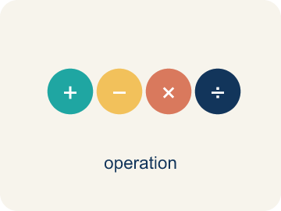 | Multiply Decimals Multiplicar decimales  Find the product of decimals, then use place value to place the decimal point.  Example: 3.4 × 2.6 = 8.84
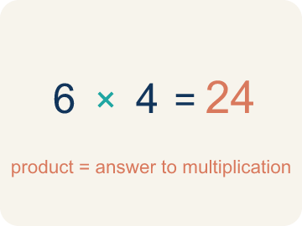 | Product Producto  The answer when you multiply.  Example: 4 × 7 = 28, so the product is 28
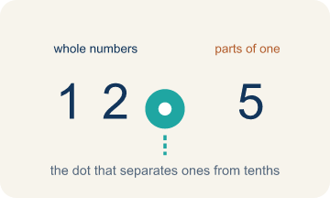 | Decimal point Punto decimal  The dot that splits the whole number from the part after it.  Example: In 3.25, the decimal point separates 3 (ones) from 25 (tenths and hundredths)
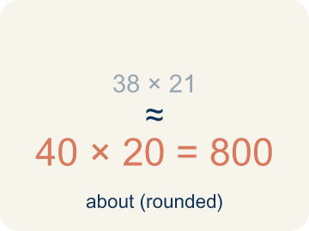 | Estimate Estimar  A close answer you get by rounding first.  Example: 3.7 × 4.2: round to 4 × 4 = 16, so the exact answer should be near 16
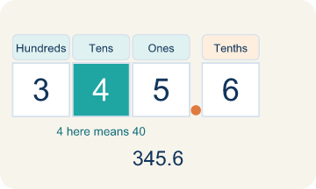 | Place value Valor posicional  What a digit is worth based on where it sits in a number.  Example: In 0.36: the 3 is in the tenths place (0.3) and the 6 is in the hundredths place (0.06)
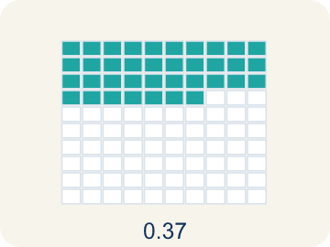 | Decimal places Cifras decimales  How many digits come after the decimal point.  Example: 3.4 (1 place) × 2.6 (1 place) = 8.84 (2 places total)

Guided Notes
Fill in each blank as we go. Use the Word Bank to help you.
WORD BANK
Multiply Decimals • Product • Decimal point • Estimate • Place value • Decimal places

1. Count the decimal places in BOTH factors to place the ________________ ________________.
2. The answer to a multiplication problem is the ________________.
3. The dot that separates whole numbers from parts of a whole is the ________________.
4. Finding an answer that is close but not exact, to check if a product is reasonable, is to ________________.
5. The value a digit has based on its position is its ________________.
6. To place the point in a product, I count the total number of ________________ in both factors.

Write About the Math
How do you multiply decimals to find the total cost? How can estimation help you check?
¿Cómo multiplicas decimales para hallar el costo total? ¿Cómo te puede ayudar estimar a comprobarlo?
Say your answer to a partner first. Then write it, using at least two of these words:
☐ Product · Producto
☐ Decimal point · Punto decimal
☐ Estimate · Estimar
☐ Place value · Valor posicional
☐ Decimal places · Cifras decimales
Model: Rounding the factors gives a reasonable estimate of the product. — Students round to about 5 × $13 = $65 (or 4 × $13) to predict the cost is in the $50-$65 range, naming 4.5 and 12.60 as the factors.

Start Most language support
Complete the frames. Use the word bank.
Completa las oraciones. Usa el banco de palabras.
The total cost is $___ because 3.5 × $6.80 = $___, and I can estimate by rounding to ___ × ___ = ___.
My answer is ___ because ___.
Mi respuesta es ___ porque ___.

Build Some language support
Write two connected sentences. Use because, so, or but.
Escribe dos oraciones conectadas. Usa porque, entonces o pero.
My claim is ___.
Mi afirmación es ___.
My evidence is ___, so ___.
Mi evidencia es ___, entonces ___.

Explain Light language support
Write a claim, give math evidence, and explain your reasoning.
Escribe una afirmación, da evidencia matemática y explica tu razonamiento.

Check Your Explanation three quick checks
☐ I answered the question.
☐ I used math evidence: numbers, an equation, or a model.
☐ I used at least two math words.

Worked Example

Watch & Read I Do — follow along with your teacher
Space Station Material Costs
The station needs 4.5 meters of heat shielding that costs $12.60 per meter. Commander Diaz needs to calculate the total cost before submitting the supply order. What is the total cost of the shielding?

Think about:
• What two quantities are being multiplied?
• How many total decimal places do the two factors have?
• How can estimating help you check if your answer is reasonable?
• Where does the decimal point go in the product?

Solved Example I Do — watch each step
Problem: What is 3.4 × 2.6?
A) 8.84
B) 88.4
C) 0.884
D) 8.48
Step 1: 34 × 26 = 884.
Step 2: There are 2 total decimal places (1 + 1), so place the decimal to get 8.84.
Answer: A. 8.84

Guided Practice

Solve Together We Do — work with your class
Problem: What is 0.7 × 1.5?
A) 1.05
B) 10.5
C) 0.105
D) 1.50
Step 1:

Step 2:

Answer:

A family is buying 3.5 pounds of deli meat that costs $6.80 per pound at the grocery store.
How do you multiply decimals to find the total cost? How can estimation help you check?

Sentence frame: The total cost is $___ because 3.5 × $6.80 = $___, and I can estimate by rounding to ___ × ___ = ___.

Turn & Talk discuss with a partner
1. [Launch] The station needs 4.5 meters of heat shielding at $12.60 per meter. About how much will it cost, and how did you estimate before multiplying?
Start with: I estimate about $___ because 4.5 is close to ___ and $12.60 is close to ___.
Estimo unos $___ porque 4.5 está cerca de ___ y $12.60 está cerca de ___.
Word bank: product, decimal point, estimate, place value, decimal places
2. [Explore] When you multiplied 4.5 × 12.60, how did you decide where to put the decimal point in the product?
Start with: I counted ___ decimal places in the factors.
Conté ___ lugares decimales en los factores.
Word bank: product, decimal point, estimate, place value, decimal places
3. [Connect] A family buys 3.5 pounds of deli meat at $6.80 per pound. How do you multiply the decimals to find the total cost, and how can estimating check it?
Start with: The total cost is $___ because I multiplied ___ × ___.
El costo total es $___ porque multipliqué ___ × ___.
Word bank: product, decimal point, estimate, place value, decimal places
4. [Reflect] How is placing the decimal point in a product different from lining up decimals when adding? Why don't you line up the points to multiply?
Start with: To multiply I ___ the decimal places, but to add I ___ the decimal points.
Para multiplicar ___ los lugares decimales, pero para sumar ___ los puntos decimales.
Word bank: product, decimal point, estimate, place value, decimal places
5. [Practice] During practice on Multiply Decimals, what strategy did you use when a problem felt tricky?
Start with: I counted ___ decimal places in the factors.
Conté ___ lugares decimales en los factores.
Word bank: product, decimal point, estimate, place value, decimal places

Independent Practice

On Your Own You Do — show your work
Solve each problem. Show your thinking in the work box.

Level 1 Support extra scaffolding
1. What is 5.3 × 4?
A) 21.2
B) 2.12
C) 212
D) 20.12

2. Which estimate is closest to 4.8 × 3.2?
A) 5 × 3 = 15
B) 4 × 3 = 12
C) 5 × 4 = 20
D) 48 × 32 = 1,536

On Level grade-level practice
3. A car travels 55.5 miles per hour for 2.4 hours. How far does it go?
A) 133.2 miles
B) 13.32 miles
C) 1,332 miles
D) 57.9 miles

Exit Ticket
Answer on your own. This shows what you learned today.
★ What is 4.6 × 2.3?
A) 10.58
B) 105.8
C) 1.058
D) 10.48

