UNIT 2 · LESSON 6 STANDARD 6.NOS.2

Divide Multi-Digit Numbers Using an Algorithm
Student Notes Packet
Name: ______________________ Date: ____________ Period: ________

Today's Goals
Content: I can divide multi-digit whole numbers and explain the meaning of the quotient and remainder.
Language: I can explain my division using the words dividend, divisor, quotient, and remainder.

Key Vocabulary
Look at the picture, read the word, then read what it means.
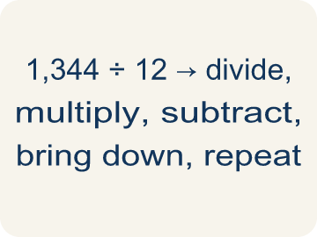 | Algorithm Algoritmo  A step-by-step set of rules or instructions to solve a math problem.
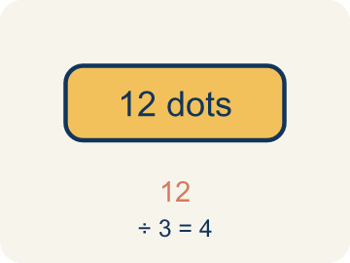 | Dividend Dividendo  The total number being divided into equal groups (the number inside the division bracket).  Example: In 1,344 ÷ 12 = 112, the dividend is 1,344 — the total amount being divided
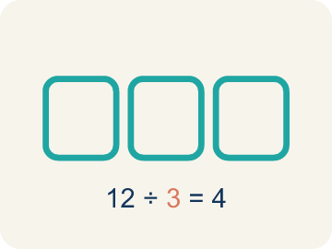 | Divisor Divisor  The number of equal groups you are dividing into (the number outside the division bracket).  Example: In 1,344 ÷ 12 = 112, the divisor is 12 — the number of equal groups
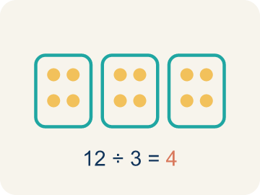 | Quotient Cociente  The answer when you divide.  Example: In 156 ÷ 12 = 13, the quotient is 13 — there are 13 groups
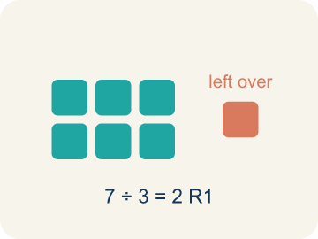 | Remainder Residuo  What is left over when a number does not divide evenly.  Example: 17 ÷ 5 = 3 R 2 means 3 groups of 5 with 2 left over
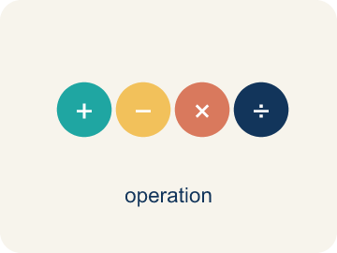 | Divide Multi-Digit Numbers Dividir números de varias cifras  Separate a multi-digit number into equal groups to find a quotient.  Example: 1,344 ÷ 12 = 112
Long division División larga
A method that repeats four steps — divide, multiply, subtract, bring down — until there are no digits left to bring down.
Example: 1,344 ÷ 12 → divide, multiply, subtract, bring down, repeat
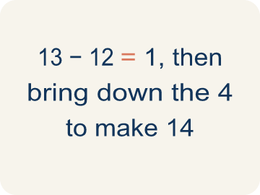 | Bring down Bajar el dígito  The fourth step of long division: move the next digit of the dividend down next to what is left, then start the cycle again.  Example: 13 − 12 = 1, then bring down the 4 to make 14

Guided Notes
Fill in each blank as we go. Use the Word Bank to help you.
WORD BANK
Algorithm • Dividend • Divisor • Quotient • Remainder • Divide Multi-Digit Numbers • Long division • Bring down

1. A step-by-step set of rules to solve a problem is called an ________________.
2. In 84 ÷ 7, the total amount 84 being divided is the ________________.
3. In 84 ÷ 7, the number 7 that you divide by is the ________________.
4. The answer to a division problem is called the ________________.
5. When a number does not divide evenly, the amount left over is the ________________.
6. Long division repeats four steps: divide, multiply, subtract, ________________ ________________.
7. The method that repeats divide, multiply, subtract, and bring down is called ________________.
8. After you subtract in long division, the next step is to ________________ the next digit.

Write About the Math
How does multi-digit division help the school figure out how many pencils each classroom gets?
¿Cómo ayuda la división de varios dígitos a la escuela a averiguar cuántos lápices recibe cada salón?
Say your answer to a partner first. Then write it, using at least two of these words:
☐ Algorithm · Algoritmo
☐ Dividend · Dividendo
☐ Divisor · Divisor
☐ Quotient · Cociente
☐ Remainder · Residuo
Model: Estimating with friendly numbers checks whether the quotient is reasonable. — Students estimate using 1,200 ÷ 12 = 100 (or similar) to predict roughly 100+ bars per section, identifying 1,344 as the dividend and 12 as the divisor.

Start Most language support
Complete the frames. Use the word bank.
Completa las oraciones. Usa el banco de palabras.
Each classroom gets ___ pencils because 1,680 ÷ 24 = ___.
My answer is ___ because ___.
Mi respuesta es ___ porque ___.

Build Some language support
Write two connected sentences. Use because, so, or but.
Escribe dos oraciones conectadas. Usa porque, entonces o pero.
My claim is ___.
Mi afirmación es ___.
My evidence is ___, so ___.
Mi evidencia es ___, entonces ___.

Explain Light language support
Write a claim, give math evidence, and explain your reasoning.
Escribe una afirmación, da evidencia matemática y explica tu razonamiento.

Check Your Explanation three quick checks
☐ I answered the question.
☐ I used math evidence: numbers, an equation, or a model.
☐ I used at least two math words.

Worked Example

Watch & Read I Do — follow along with your teacher
Space Station Supply Division
The space station has 1,344 nutrition bars that must be divided equally among 12 crew sections for a 4-week rotation. How many bars does each section receive?

Think about:
• What total amount needs to be divided?
• How many groups are the supplies being split into?
• Will each section get the same amount with none left over?
• What strategy would you use to divide such a large number?

Solved Example I Do — watch each step
Problem: What is 936 ÷ 12?
A) 78
B) 87
C) 68
D) 76
Step 1: 12 × 78 = 936.
Step 2: You can verify: 12 × 70 = 840, 12 × 8 = 96, 840 + 96 = 936.
Answer: A. 78

Guided Practice

Solve Together We Do — work with your class
Problem: What is 2,485 ÷ 5?
A) 497
B) 487
C) 507
D) 496
Step 1:

Step 2:

Answer:

A school is ordering 1,680 pencils to distribute equally to 24 classrooms for the school year.
How does multi-digit division help the school figure out how many pencils each classroom gets?

Sentence frame: Each classroom gets ___ pencils because 1,680 ÷ 24 = ___.

Turn & Talk discuss with a partner
1. [Launch] The station must divide 1,344 nutrition bars equally among 12 crew sections. Before dividing, about how many bars should each section get, and how do you know?
Start with: Each section gets about ___ bars because 1,344 is close to ___.
Cada sección recibe unas ___ barras porque 1,344 está cerca de ___.
Word bank: dividend, divisor, quotient, estimate, bring down
2. [Explore] You used long division for 1,344 ÷ 12. Walk through your divide, multiply, subtract, and bring down steps — what did each one tell you?
Start with: First I divided ___ by 12 and wrote ___ in the quotient.
Primero dividí ___ entre 12 y escribí ___ en el cociente.
Word bank: bring down, dividend, divisor, quotient, remainder
3. [Connect] The station's observation deck seats 2,160 visitors equally across 18 viewing sections. How does multi-digit division tell each section's seat count, and how can you check it?
Start with: Each section gets ___ seats because 2,160 ÷ 18 = ___.
Cada sección recibe ___ asientos porque 2,160 ÷ 18 = ___.
Word bank: dividend, divisor, quotient, bring down, equally
4. [Reflect] In a division problem, what is the difference between the quotient and the remainder, and what does each one tell you?
Start with: The quotient tells me ___, and the remainder tells me ___.
El cociente me dice ___, y el residuo me dice ___.
Word bank: quotient, remainder, dividend, divisor, divide
5. [Practice] During practice on Divide Multi-Digit Numbers, what strategy did you use when a problem felt tricky?
Start with: First I divided ___ by 12 and wrote ___ in the quotient.
Primero dividí ___ entre 12 y escribí ___ en el cociente.
Word bank: Dividend, Divisor, Quotient, Remainder

Independent Practice

On Your Own You Do — show your work
Solve each problem. Show your thinking in the work box.

Level 1 Support extra scaffolding
1. What is 756 ÷ 9?
A) 84
B) 83
C) 94
D) 86

2. What is 1,125 ÷ 9?
A) 125
B) 115
C) 135
D) 124

On Level grade-level practice
3. A warehouse has 2,184 items to pack into boxes of 14. How many boxes are needed?
A) 156 boxes
B) 146 boxes
C) 166 boxes
D) 155 boxes

Exit Ticket
Answer on your own. This shows what you learned today.
★ What is 2,352 ÷ 16?
A) 147
B) 137
C) 157
D) 146

