Divide Decimals Using an Algorithm — Homework
Lesson 2-7 • Standard 6.NOS.3
Name: ______________________ Period: ______ Date: ____________

Today's Goals
Content: I can divide with decimals by making the divisor a whole number first.
Language: I can explain my work using the words dividend, divisor, quotient, and equivalent division.

Key Words
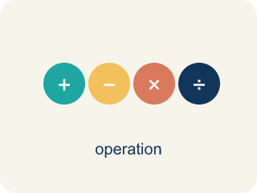
Divide Decimals (Dividir decimales) — Find a quotient with decimals by making the divisor a whole number first.
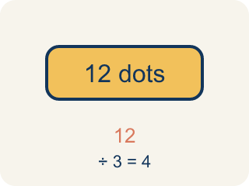
Dividend (Dividendo) — The number you are splitting up in a division problem.
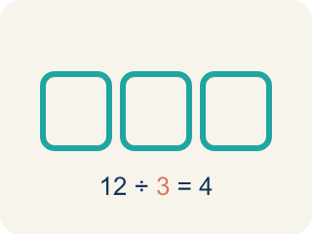
Divisor (Divisor) — The number you split by in a division problem.
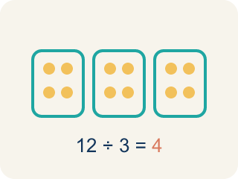
Quotient (Cociente) — The answer when you divide.
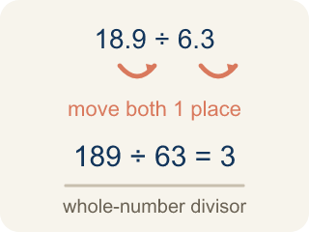
Decimal Division Algorithm (Algoritmo de división decimal) — The steps for dividing decimals: make the divisor a whole number, move the dividend's point the same number of places, then divide.
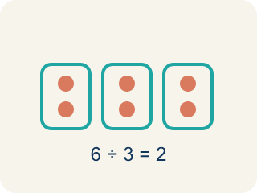
Equivalent division (División equivalente) — Multiplying both numbers by 10 or 100 gives the same answer.

Practice
Show your work. Use the blank space under each problem.
1. What is 14.4 ÷ 1.2?
A. 12
B. 1.2
C. 120
D. 0.12
______________________________________________________________________
2. What is 3.78 ÷ 0.6?
A. 6.3
B. 63
C. 0.63
D. 0.063
______________________________________________________________________
3. Solve each decimal division problem.
Division Problem | Quotient
9.6 ÷ 0.8
15.6 ÷ 1.3
24.5 ÷ 3.5
5.76 ÷ 0.24
11.34 ÷ 0.9
______________________________________________________________________
4. Match each decimal division to its quotient.
Item | Answer choices
____ 7.2 ÷ 0.8 | F. 1.2
____ 4.56 ÷ 0.6 | E. 7
____ 13.2 ÷ 1.2 | D. 30
____ 3.6 ÷ 0.12 | C. 11
____ 10.5 ÷ 1.5 | B. 7.6
____ 0.96 ÷ 0.8 | A. 9
______________________________________________________________________
5. A water tank holds 19.2 liters. It is poured into bottles that each hold 1.6 liters. How many bottles can be filled?
A. 12 bottles
B. 11 bottles
C. 13 bottles
D. 1.2 bottles
______________________________________________________________________
6. Sort: should you multiply both numbers by 10 or by 100 to make the divisor a whole number?
Groups: Multiply Both by 10 | Multiply Both by 100
• 6.3 ÷ 0.7 → multiply by 10 → __________________
• 8.4 ÷ 2.1 → multiply by 10 → __________________
• 13.6 ÷ 1.7 → multiply by 10 → __________________
• 7.56 ÷ 0.12 → multiply by 100 → __________________
• 8.28 ÷ 0.36 → multiply by 100 → __________________
• 9.45 ÷ 0.15 → multiply by 100 → __________________
______________________________________________________________________
7. Spot the Common Mistake
Step 1 (Problem): Solve 9.6 ÷ 0.12.
Step 2 (Count how far to move): 0.12 has 2 decimal places, so BOTH numbers move 2 places right. The divisor: 0.12 → 12.
Step 3 (Move the dividend the same 2 places): 9.6 only has one digit after the point, so the student moved it just 1 place: 9.6 → 96. New problem: 96 ÷ 12 = 8.
Which step has the mistake? Explain and fix it:
______________________________________________________________________
______________________________________________________________________
______________________________________________________________________
8. What is 4.8 ÷ 0.6?
A. 8
B. 0.8
C. 80
D. 4.2
______________________________________________________________________
9. What is 9.45 ÷ 0.9?
A. 10.5
B. 1.05
C. 105
D. 9.5
______________________________________________________________________
10. A ribbon is 7.2 meters long and is cut into 0.8-meter pieces. How many pieces are there?
A. 9
B. 8
C. 7
D. 10
______________________________________________________________________

Answer Key (Teacher)
1. A. 12
Multiply both by 10: 144 ÷ 12 = 12.
Watch for: A common mistake in Divide Decimals is moving the decimal point in the divisor but forgetting to move it the same number of places in the dividend. For example, in 6.4 ÷ 0.8 a student changes 0.8 to 8 but leaves the dividend as 6.4, then divides 6.4 ÷ 8 = 0.8 instead of moving both points to get 64 ÷ 8 = 8. A second version of this mistake happens when the divisor has two decimal places, like 0.12: students move both points only 1 place instead of 2, turning 9.6 ÷ 0.12 into 96 ÷ 1.2 instead of the correct 960 ÷ 12. Count the divisor's decimal places first, then move BOTH points that same number of places.
2. A. 6.3
Multiply both by 10: 37.8 ÷ 6 = 6.3.
Watch for: A common mistake in Divide Decimals is moving the decimal point in the divisor but forgetting to move it the same number of places in the dividend. For example, in 6.4 ÷ 0.8 a student changes 0.8 to 8 but leaves the dividend as 6.4, then divides 6.4 ÷ 8 = 0.8 instead of moving both points to get 64 ÷ 8 = 8. A second version of this mistake happens when the divisor has two decimal places, like 0.12: students move both points only 1 place instead of 2, turning 9.6 ÷ 0.12 into 96 ÷ 1.2 instead of the correct 960 ÷ 12. Count the divisor's decimal places first, then move BOTH points that same number of places.
3. Solve each decimal division problem.
9.6 ÷ 0.8 → 12
15.6 ÷ 1.3 → 12
24.5 ÷ 3.5 → 7
5.76 ÷ 0.24 → 24
11.34 ÷ 0.9 → 12.6

4. Matches:
7.2 ÷ 0.8 → 9
4.56 ÷ 0.6 → 7.6
13.2 ÷ 1.2 → 11
3.6 ÷ 0.12 → 30
10.5 ÷ 1.5 → 7
0.96 ÷ 0.8 → 1.2

5. A. 12 bottles
19.2 ÷ 1.6: multiply both by 10 → 192 ÷ 16 = 12 bottles.
Watch for: A common mistake in Divide Decimals is moving the decimal point in the divisor but forgetting to move it the same number of places in the dividend. For example, in 6.4 ÷ 0.8 a student changes 0.8 to 8 but leaves the dividend as 6.4, then divides 6.4 ÷ 8 = 0.8 instead of moving both points to get 64 ÷ 8 = 8. A second version of this mistake happens when the divisor has two decimal places, like 0.12: students move both points only 1 place instead of 2, turning 9.6 ÷ 0.12 into 96 ÷ 1.2 instead of the correct 960 ÷ 12. Count the divisor's decimal places first, then move BOTH points that same number of places.
6. Correct groups:
6.3 ÷ 0.7 → multiply by 10 → Multiply Both by 10
8.4 ÷ 2.1 → multiply by 10 → Multiply Both by 10
13.6 ÷ 1.7 → multiply by 10 → Multiply Both by 10
7.56 ÷ 0.12 → multiply by 100 → Multiply Both by 100
8.28 ÷ 0.36 → multiply by 100 → Multiply Both by 100
9.45 ÷ 0.15 → multiply by 100 → Multiply Both by 100

7. Spot the Common Mistake
The mistake is in Step 3.
Correct work: Both numbers must move the SAME number of places — 2, not 1. 9.6 runs out of digits after one place, so you add a placeholder zero to move the second place: 9.6 → 96 → 960. The real problem is 960 ÷ 12 = 80, so 9.6 ÷ 0.12 = 80. Estimate to confirm: 0.12 is tiny, so many of them fit in 9.6 — the quotient must be large, not 8. Check: 80 × 0.12 = 9.6. ✓
Watch for: In the last step the dividend moved only 1 place while the divisor moved 2, so the two numbers no longer match. Adding a placeholder zero lets 9.6 move both places to 960, making the real problem 960 ÷ 12 = 80. That size is reasonable, because a great many 0.12s fit inside 9.6.
8. A. 8
Multiply both by 10: 48 ÷ 6 = 8.
Watch for: A common mistake in Divide Decimals is moving the decimal point in the divisor but forgetting to move it the same number of places in the dividend. For example, in 6.4 ÷ 0.8 a student changes 0.8 to 8 but leaves the dividend as 6.4, then divides 6.4 ÷ 8 = 0.8 instead of moving both points to get 64 ÷ 8 = 8. A second version of this mistake happens when the divisor has two decimal places, like 0.12: students move both points only 1 place instead of 2, turning 9.6 ÷ 0.12 into 96 ÷ 1.2 instead of the correct 960 ÷ 12. Count the divisor's decimal places first, then move BOTH points that same number of places.
9. A. 10.5
Multiply both by 10: 94.5 ÷ 9 = 10.5.
Watch for: A common mistake in Divide Decimals is moving the decimal point in the divisor but forgetting to move it the same number of places in the dividend. For example, in 6.4 ÷ 0.8 a student changes 0.8 to 8 but leaves the dividend as 6.4, then divides 6.4 ÷ 8 = 0.8 instead of moving both points to get 64 ÷ 8 = 8. A second version of this mistake happens when the divisor has two decimal places, like 0.12: students move both points only 1 place instead of 2, turning 9.6 ÷ 0.12 into 96 ÷ 1.2 instead of the correct 960 ÷ 12. Count the divisor's decimal places first, then move BOTH points that same number of places.
10. A. 9
7.2 ÷ 0.8 = 72 ÷ 8 = 9 pieces.
Watch for: A common mistake in Divide Decimals is moving the decimal point in the divisor but forgetting to move it the same number of places in the dividend. For example, in 6.4 ÷ 0.8 a student changes 0.8 to 8 but leaves the dividend as 6.4, then divides 6.4 ÷ 8 = 0.8 instead of moving both points to get 64 ÷ 8 = 8. A second version of this mistake happens when the divisor has two decimal places, like 0.12: students move both points only 1 place instead of 2, turning 9.6 ÷ 0.12 into 96 ÷ 1.2 instead of the correct 960 ÷ 12. Count the divisor's decimal places first, then move BOTH points that same number of places.

