Volume of Rectangular Prisms — Homework
Lesson 5-10 • Standard 6.GR.2
Name: ______________________ Period: ______ Date: ____________

Today's Goals
Content: I can find the volume of a rectangular prism, including ones with fractional edge lengths, using base area × height.
Language: I can explain my work using the words volume, rectangular prism, dimensions, and base area.

Key Words
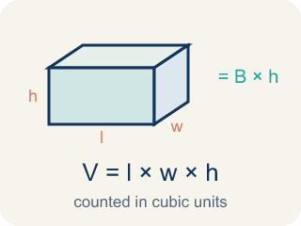
Volume of Rectangular Prisms (Volumen de prismas rectangulares) — The space inside a rectangular prism. Formula: V = Bh = l × w × h.

Volume (Volumen) — How much space is inside a solid shape.
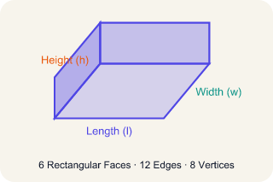
Rectangular prism (Prisma rectangular) — A solid box shape with six flat rectangle sides.
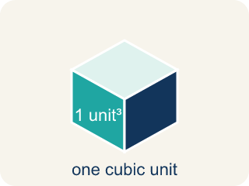
Cubic units (Unidades cúbicas) — The units used to measure space inside, like cubic inches.
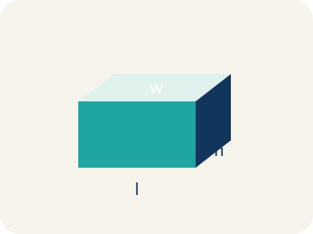
Dimensions (Dimensiones) — How long, how wide, and how tall a shape is.
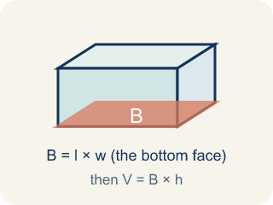
Base area (Área de la base) — The area of the bottom of a solid. Volume = base area × height.

Practice
Show your work. Use the blank space under each problem.
1. What is the volume of a rectangular prism with l = 4 in, w = 3 in, h = 5 in?
A. 60 in³
B. 12 in³
C. 60 in²
D. 24 in³
______________________________________________________________________
2. A box has a volume of 36 cm³. Its length is 6 cm and width is 3 cm. What is the height?
A. 2 cm
B. 6 cm
C. 3 cm
D. 12 cm
______________________________________________________________________
3. Find the missing dimension or volume for each container.
Container | Length | Width | Height | Volume
Box A | 12 in | 5 in | 3 in
Box B | 7 cm |  | 4 cm | 168 cm³
Box C |  | 8 ft | 5 ft | 240 ft³
______________________________________________________________________
4. Two boxes: Box A is 10 × 5 × 4 inches. Box B is 8 × 6 × 5 inches. Which has more volume and by how much?
A. Box B by 40 in³
B. Box A by 40 in³
C. Box B by 60 in³
D. They're equal
______________________________________________________________________
5. Sort each item into the correct group.
• undefined → __________________
• undefined → __________________
• undefined → __________________
• undefined → __________________
______________________________________________________________________
6. Spot the Common Mistake
Step 1 (Dimensions): A box is 6 in long, 4 in wide, and 1/2 in tall.
Step 2 (Formula): V = length × width × height
Step 3 (Calculate): V = 6 × 4 × 1/2, and the student dropped the 1/2: V = 6 × 4 = 24 cubic in
Step 4 (Answer): Volume = 24 cubic in
Which step has the mistake? Explain and fix it:
______________________________________________________________________
______________________________________________________________________
______________________________________________________________________
7. What is the volume of a prism with edge lengths 1/2 m, 3 m, and 4 m?
A. 7.5 m³
B. 12 m³
C. 6 m³
D. 3 m³
______________________________________________________________________
8. A cube has an edge length of 5 cm. What is its volume?
A. 125 cm³
B. 15 cm³
C. 25 cm³
D. 75 cm³
______________________________________________________________________
9. A time-capsule box measures 6 in long, 4 in wide, and 3 in tall. What is its volume?
A. 72 cubic in
B. 13 cubic in
C. 24 cubic in
D. 72 square in
______________________________________________________________________
10. Two storage boxes are ready to pack. Box A is 5 × 5 × 2 inches and Box B is 4 × 4 × 3 inches. Which box holds more?
A. Box A, because 50 cubic in is more than 48 cubic in
B. Box B, because 48 cubic in is more than 50 cubic in
C. They hold the same amount
D. Box B, because it is taller
______________________________________________________________________

Answer Key (Teacher)
1. A. 60 in³
V = l × w × h = 4 × 3 × 5 = 60 cubic inches.
Watch for: A common mistake in Volume of Rectangular Prisms is rounding a fractional edge length to the nearest whole number before multiplying, instead of using the exact fraction or decimal. For a box that is 2 ft × 1.5 ft × 1 ft, a student might round 1.5 down to 1 and compute 2 × 1 × 1 = 2 ft³, but the correct volume uses the exact edge length: 2 × 1.5 × 1 = 3 ft³ — a full cubic foot larger. Before you submit, ask: 'Did I multiply using the exact fractional or decimal edge length, or did I round it off first?'
2. A. 2 cm
V = l × w × h → 36 = 6 × 3 × h → 36 = 18h → h = 2 cm.
Watch for: A common mistake in Volume of Rectangular Prisms is rounding a fractional edge length to the nearest whole number before multiplying, instead of using the exact fraction or decimal. For a box that is 2 ft × 1.5 ft × 1 ft, a student might round 1.5 down to 1 and compute 2 × 1 × 1 = 2 ft³, but the correct volume uses the exact edge length: 2 × 1.5 × 1 = 3 ft³ — a full cubic foot larger. Before you submit, ask: 'Did I multiply using the exact fractional or decimal edge length, or did I round it off first?'
3. Find the missing dimension or volume for each container.
Box A — Volume: 180 in³
Box B — Width: 6 cm
Box C — Length: 6 ft

4. A. Box B by 40 in³
Box A: 10 × 5 × 4 = 200 in³. Box B: 8 × 6 × 5 = 240 in³. Box B is bigger by 40 in³.
Watch for: A common mistake in Volume of Rectangular Prisms is rounding a fractional edge length to the nearest whole number before multiplying, instead of using the exact fraction or decimal. For a box that is 2 ft × 1.5 ft × 1 ft, a student might round 1.5 down to 1 and compute 2 × 1 × 1 = 2 ft³, but the correct volume uses the exact edge length: 2 × 1.5 × 1 = 3 ft³ — a full cubic foot larger. Before you submit, ask: 'Did I multiply using the exact fractional or decimal edge length, or did I round it off first?'
5. Correct groups:
undefined → undefined
undefined → undefined
undefined → undefined
undefined → undefined

6. Spot the Common Mistake
The mistake is in Step 3.
Correct work: The student ignored the fractional edge of 1/2 in. A fractional edge still counts: V = 6 × 4 × 1/2 = 24 × 1/2 = 12 cubic in.
Watch for: The Calculate step threw away the 1/2 in height, but a fractional edge is still an edge. Multiply all three: V = 6 × 4 × 1/2 = 24 × 1/2 = 12 cubic in. A half-inch height makes the volume half of 24, not equal to it.
7. C. 6 m³
V = 1/2 × 3 × 4 = 6 m³.
Watch for: A common mistake in Volume of Rectangular Prisms is rounding a fractional edge length to the nearest whole number before multiplying, instead of using the exact fraction or decimal. For a box that is 2 ft × 1.5 ft × 1 ft, a student might round 1.5 down to 1 and compute 2 × 1 × 1 = 2 ft³, but the correct volume uses the exact edge length: 2 × 1.5 × 1 = 3 ft³ — a full cubic foot larger. Before you submit, ask: 'Did I multiply using the exact fractional or decimal edge length, or did I round it off first?'
8. A. 125 cm³
A cube's volume is edge³ = 5 × 5 × 5 = 125 cm³.
Watch for: A common mistake in Volume of Rectangular Prisms is rounding a fractional edge length to the nearest whole number before multiplying, instead of using the exact fraction or decimal. For a box that is 2 ft × 1.5 ft × 1 ft, a student might round 1.5 down to 1 and compute 2 × 1 × 1 = 2 ft³, but the correct volume uses the exact edge length: 2 × 1.5 × 1 = 3 ft³ — a full cubic foot larger. Before you submit, ask: 'Did I multiply using the exact fractional or decimal edge length, or did I round it off first?'
9. A. 72 cubic in
V = length × width × height = 6 × 4 × 3 = 72 cubic in. Volume uses cubic units.
Watch for: A common mistake in Volume of Rectangular Prisms is rounding a fractional edge length to the nearest whole number before multiplying, instead of using the exact fraction or decimal. For a box that is 2 ft × 1.5 ft × 1 ft, a student might round 1.5 down to 1 and compute 2 × 1 × 1 = 2 ft³, but the correct volume uses the exact edge length: 2 × 1.5 × 1 = 3 ft³ — a full cubic foot larger. Before you submit, ask: 'Did I multiply using the exact fractional or decimal edge length, or did I round it off first?'
10. A. Box A, because 50 cubic in is more than 48 cubic in
Box A: 5 × 5 × 2 = 50 cubic in. Box B: 4 × 4 × 3 = 48 cubic in. 50 > 48, so Box A holds more.
Watch for: A common mistake in Volume of Rectangular Prisms is rounding a fractional edge length to the nearest whole number before multiplying, instead of using the exact fraction or decimal. For a box that is 2 ft × 1.5 ft × 1 ft, a student might round 1.5 down to 1 and compute 2 × 1 × 1 = 2 ft³, but the correct volume uses the exact edge length: 2 × 1.5 × 1 = 3 ft³ — a full cubic foot larger. Before you submit, ask: 'Did I multiply using the exact fractional or decimal edge length, or did I round it off first?'

