UNIT 5 · LESSON 6 STANDARD 6.GR.4

Represent Three-Dimensional Figures in Two Dimensions
Student Notes Packet
Name: ______________________ Date: ____________ Period: ________

Today's Goals
Content: I can find the surface area of a solid by using its net.
Language: I can explain my work using the words surface area, net, face, and two-dimensional.

Key Vocabulary
Look at the picture, read the word, then read what it means.
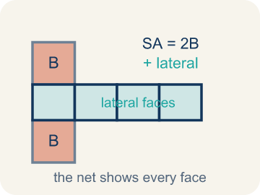 | Surface Area Using Nets Área de superficie usando redes  The total area of all the faces of a solid. A net unfolds the solid flat so you can see every face and add their areas.  Example: A box with 6 faces: 2(8×5) + 2(8×3) + 2(5×3) = 158 square units
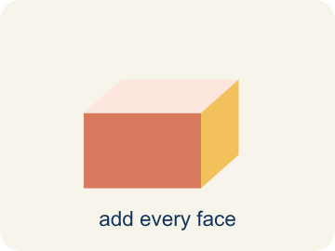 | Surface area Área de superficie  The total area of all the flat sides of a solid.  Example: A box 6 × 4 × 2: SA = 2(24) + 2(12) + 2(8) = 88 in² — like wrapping paper needed
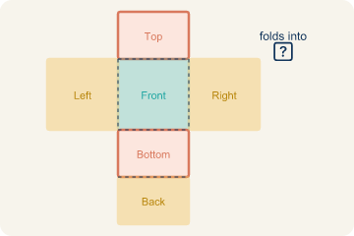 | Net Plantilla (desarrollo plano)  A flat shape that folds up into a solid.  Example: Cut along the edges of a cereal box and unfold it flat — you see all 6 faces
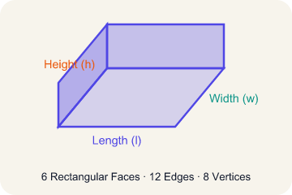 | Face Cara  One flat side of a solid shape.  Example: A rectangular prism has 6 faces: top, bottom, front, back, left, right
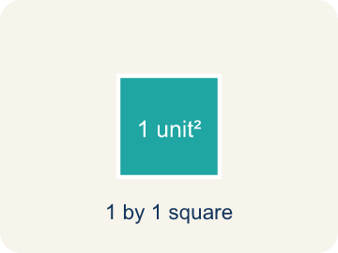 | Two-dimensional Bidimensional  A flat shape with length and width, but no thickness.  Example: A rectangle drawn on paper is 2D — it has length and width but no depth
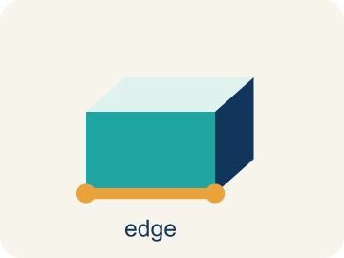 | Edge Arista  The line where two flat sides of a solid meet.  Example: A cube has 12 edges — the lines where two flat faces connect

Guided Notes
Fill in each blank as we go. Use the Word Bank to help you.
WORD BANK
Surface Area Using Nets • Surface area • Net • Face • Two-dimensional • Edge

1. The total area of every face, found by adding the faces in a net, is the ________________.
2. The total area of all the faces of a solid is its ________________.
3. A flat pattern that folds up into a solid is a ________________.
4. A flat surface of a solid figure is a ________________.
5. A flat shape with length and width but no thickness is ________________.
6. A line segment where two faces meet is an ________________.

Write About the Math
How many sheets of wrapping paper are needed to cover the entire box?
¿Cuántas hojas de papel de regalo se necesitan para cubrir toda la caja?
Say your answer to a partner first. Then write it, using at least two of these words:
☐ Surface area · Área de superficie
☐ Net · Plantilla (desarrollo plano)
☐ Face · Cara
☐ Two-dimensional · Bidimensional
☐ Edge · Arista
Model: A net lays every face flat so you can see and measure all six faces. — Students explain a rectangular prism has 6 faces, and the net unfolds the solid into a flat (two-dimensional) pattern so every face is visible to measure.

Start Most language support
Complete the frames. Use the word bank.
Completa las oraciones. Usa el banco de palabras.
The box's surface area is ___ in² because SA = 2(___×___) + 2(___×___) + 2(___×___) = ___ + ___ + ___ = ___. You need ___ sheets because ___ ÷ 400 ≈ ___.
My answer is ___ because ___.
Mi respuesta es ___ porque ___.

Build Some language support
Write two connected sentences. Use because, so, or but.
Escribe dos oraciones conectadas. Usa porque, entonces o pero.
My claim is ___.
Mi afirmación es ___.
My evidence is ___, so ___.
Mi evidencia es ___, entonces ___.

Explain Light language support
Write a claim, give math evidence, and explain your reasoning.
Escribe una afirmación, da evidencia matemática y explica tu razonamiento.

Check Your Explanation three quick checks
☐ I answered the question.
☐ I used math evidence: numbers, an equation, or a model.
☐ I used at least two math words.

Worked Example

Watch & Read I Do — follow along with your teacher
Time Capsule Project
Your class is designing custom wrapping paper for time capsule boxes. To figure out how much paper you need, you have to find the total surface area of each box. The trick? Unfold the box into a net so you can see every face laid flat!

Think about:
• How many faces does a rectangular prism have?
• What shapes do you see when the box is unfolded?
• Are all the faces the same size?
• Is there more than one way to unfold a box into a net?
• How does a net help you find surface area more easily than looking at the 3D shape?

Solved Example I Do — watch each step
Problem: A rectangular prism has l = 6 in, w = 4 in, h = 2 in. What is its surface area?
A) 88 in²
B) 48 in²
C) 88 in³
D) 44 in²
Step 1: SA = 2(6×4) + 2(6×2) + 2(4×2) = 48 + 24 + 16 = 88 in².
Answer: A. 88 in²

Guided Practice

Solve Together We Do — work with your class
Problem: How many faces does a rectangular prism have?
A) 6
B) 4
C) 8
D) 12
Step 1:

Step 2:

Answer:

A gift shop wraps boxes with decorative paper. A box is 14 inches long, 10 inches wide, and 6 inches tall. One sheet of wrapping paper covers 400 square inches.
How many sheets of wrapping paper are needed to cover the entire box?

Sentence frame: The box's surface area is ___ in² because SA = 2(___×___) + 2(___×___) + 2(___×___) = ___ + ___ + ___ = ___. You need ___ sheets because ___ ÷ 400 ≈ ___.

Turn & Talk discuss with a partner
1. [Launch] To find how much wrapping paper a time capsule box needs, why is unfolding it into a net more helpful than looking at the 3D box?
Start with: A net helps because it shows all ___ faces laid ___.
Una red ayuda porque muestra las ___ caras puestas ___.
Word bank: surface area, net, face, two-dimensional, edge
2. [Explore] For the box l = 8, w = 5, h = 3, you found three face pairs. How did you use the net to organize the faces into pairs, and which pair had the largest area?
Start with: The faces come in ___ pairs because opposite faces are ___.
Las caras vienen en ___ pares porque las caras opuestas son ___.
Word bank: surface area, net, face, two-dimensional, edge
3. [Connect] A gift box is 14 × 10 × 6 in and one sheet of paper covers 400 in². Talk through how to find how many sheets are needed to cover the whole box.
Start with: The surface area is ___ in² because SA = 2(14×10) + 2(14×6) + 2(10×6).
El área de superficie es ___ in² porque SA = 2(14×10) + 2(14×6) + 2(10×6).
Word bank: surface area, net, face, two-dimensional, edge
4. [Reflect] A classmate found the surface area of a box but only multiplied two of the three face pairs by 2. How would you explain why every pair must be doubled?
Start with: Every face pair must be multiplied by ___ because each shape appears ___ times.
Cada par de caras debe multiplicarse por ___ porque cada forma aparece ___ veces.
Word bank: surface area, net, face, two-dimensional, edge
5. [Practice] During practice on Surface Area Using Nets, what strategy did you use when a problem felt tricky?
Start with: The faces come in ___ pairs because opposite faces are ___.
Las caras vienen en ___ pares porque las caras opuestas son ___.
Word bank: Surface area, Net, Face, Two-dimensional

Independent Practice

On Your Own You Do — show your work
Solve each problem. Show your thinking in the work box.

Level 1 Support extra scaffolding
1. Surface area is measured in which type of unit?
A) Square units (in², cm², ft²)
B) Cubic units (in³, cm³, ft³)
C) Linear units (in, cm, ft)
D) No units needed

On Level grade-level practice
2. A cube has edges of 5 cm. What is its surface area?
A) 150 cm²
B) 125 cm²
C) 150 cm³
D) 30 cm²

Exit Ticket
Answer on your own. This shows what you learned today.
★ A rectangular prism has l = 9 in, w = 5 in, h = 3 in. What is the surface area?
A) 174 in²
B) 135 in²
C) 174 in³
D) 87 in²

