UNIT 6 · LESSON 13 STANDARD 6.NOS.4

Prime Factorization (Flagship)
Student Notes Packet
Name: ______________________ Date: ____________ Period: ________

Today's Goals
Content: I can write a number as a product of its prime factors using a factor tree.
Language: I can explain how I broke a number down using the words prime number, composite number, factor, and exponent.

Key Vocabulary
Look at the picture, read the word, then read what it means.
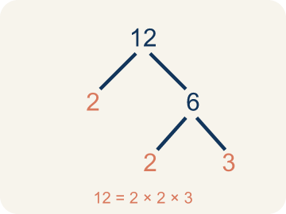 | Prime Factorization Factorización prima  Writing a whole number as a product of only prime numbers.  Example: 36 = 2 × 2 × 3 × 3 = 2² × 3²
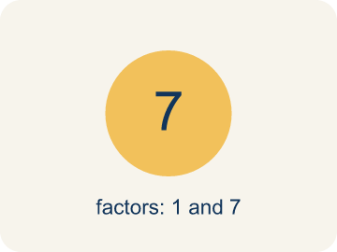 | Prime number Número primo  A number bigger than 1 that you can only divide by 1 and itself.  Example: 7 has only two factors: 1 × 7. So 7 is prime.
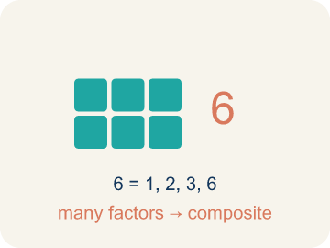 | Composite number Número compuesto  A number bigger than 1 that you can divide by more than just 1 and itself.  Example: 12 = 1 × 12, 2 × 6, 3 × 4 — six factors, so 12 is composite
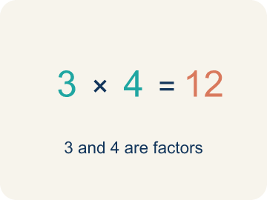 | Factor Factor  A factor of a whole number divides it evenly, with no remainder. For example, 3 is a factor of 12 because 12 ÷ 3 = 4.  Example: Factors of 12: 1, 2, 3, 4, 6, 12 — each divides 12 evenly.
Factor tree Árbol de factores
A picture that splits a number into its prime numbers, step by step.
Example: 24 → 4 × 6 → (2 × 2) × (2 × 3) → 2 × 2 × 2 × 3
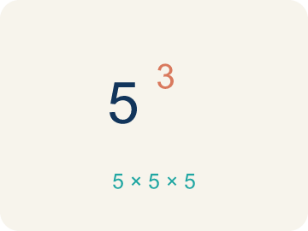 | Exponent Exponente  A small number that tells how many times to multiply a number by itself.  Example: 2³ means 2 × 2 × 2 = 8

Guided Notes
Fill in each blank as we go. Use the Word Bank to help you.
WORD BANK
Prime Factorization • Prime number • Composite number • Factor • Factor tree • Exponent

1. Writing a number as ________________ numbers multiplied together is its prime factorization.
2. A whole number greater than 1 with exactly two factors, 1 and itself, is a ________________ number.
3. A whole number greater than 1 that has more than two factors is a ________________ number.
4. A number that divides evenly into another number is called a ________________.
5. I can break a number into its prime factors step by step using a ________________.
6. In 2³, the small number 3 is the ________________ and it shows 2 is multiplied 3 times.

Write About the Math
Starting from its prime factorization, how can the gardener use the factors of 72 to decide which rectangular grids will use all 72 seed pods?
Empezando por su descomposición en factores primos, ¿cómo puede la jardinera usar los factores de 72 para decidir qué cuadrículas rectangulares usarán las 72 cápsulas de semillas?
Say your answer to a partner first. Then write it, using at least two of these words:
☐ Prime Factorization · Factorización prima
☐ Prime number · Número primo
☐ Composite number · Número compuesto
☐ Factor · Factor
☐ Factor tree · Árbol de factores
Model: 60 is composite because it has more than two factors. — Students say 60 is composite because it has more than two factors (it is divisible by numbers other than 1 and 60, such as 2, 3, 5, 6), so it can be broken down.

Start Most language support
Complete the frames. Use the word bank.
Completa las oraciones. Usa el banco de palabras.
Because 72 = ___, I can multiply combinations of those prime factors to get factors like ___, so a grid that works is ___ by ___.
My answer is ___ because ___.
Mi respuesta es ___ porque ___.

Build Some language support
Write two connected sentences. Use because, so, or but.
Escribe dos oraciones conectadas. Usa porque, entonces o pero.
My claim is ___.
Mi afirmación es ___.
My evidence is ___, so ___.
Mi evidencia es ___, entonces ___.

Explain Light language support
Write a claim, give math evidence, and explain your reasoning.
Escribe una afirmación, da evidencia matemática y explica tu razonamiento.

Check Your Explanation three quick checks
☐ I answered the question.
☐ I used math evidence: numbers, an equation, or a model.
☐ I used at least two math words.

Worked Example

Watch & Read I Do — follow along with your teacher
Space Station Cargo Breakdown
The space station received 60 supply crates. Mission Control needs to break this quantity into its prime components so the sorting robots can distribute them into equally sized pods. Help the crew find the prime factorization of 60!

Think about:
• What number are we breaking down into factors?
• What's the difference between a factor and a prime factor?
• How many different ways can we start breaking 60 apart?
• Will we always get the same prime factors no matter how we start?

Solved Example I Do — watch each step
Problem: Which of the following is a prime number?
A) 17
B) 15
C) 21
D) 9
Step 1: 17 has exactly two factors: 1 and 17.
Step 2: 15 = 3 × 5, 21 = 3 × 7, and 9 = 3 × 3, so they are all composite.
Answer: A. 17

Guided Practice

Solve Together We Do — work with your class
Problem: What is the prime factorization of 30?
A) 2 × 3 × 5
B) 5 × 6
C) 2 × 15
D) 3 × 10
Step 1:

Step 2:

Answer:

A station gardener is loading 72 seed pods into the greenhouse and wants to build a perfectly rectangular planting grid. Starting from the prime factorization of 72, she combines the prime factors to list every factor of 72 and choose a grid that uses all the pods.
Starting from its prime factorization, how can the gardener use the factors of 72 to decide which rectangular grids will use all 72 seed pods?

Sentence frame: Because 72 = ___, I can multiply combinations of those prime factors to get factors like ___, so a grid that works is ___ by ___.

Turn & Talk discuss with a partner
1. [Launch] Mission Control needs to break the 60 supply crates into prime parts. Is 60 a prime number or a composite number, and how can you tell before you even start the factor tree?
Start with: 60 is a ___ number because it has ___.
60 es un número ___ porque tiene ___.
Word bank: prime number, composite number, factor, divisible, factor tree
2. [Explore] Look at your factor tree for 60. How did you decide which numbers to break apart first, and how do you know when to stop?
Start with: I broke ___ into ___ because ___.
Separé ___ en ___ porque ___.
Word bank: prime number, composite number, factor, factor tree, prime factorization
3. [Connect] The party planner has 72 balloons. How could the prime factorization of 72 help her find every way to arrange the balloons in equal rows?
Start with: The prime factorization of 72 is ___, written with exponents as ___.
La factorización prima de 72 es ___, escrita con exponentes como ___.
Word bank: prime factorization, factor, exponent, composite number, product
4. [Reflect] How is a prime number different from a composite number, and why can every composite number be written as a product of primes?
Start with: A prime number has ___, but a composite number has ___.
Un número primo tiene ___, pero un número compuesto tiene ___.
Word bank: prime number, composite number, factor, prime factorization, product
5. [Practice] During practice on Prime Factorization, what strategy did you use when a problem felt tricky?
Start with: I broke ___ into ___ because ___.
Separé ___ en ___ porque ___.
Word bank: Prime number, Composite number, Prime factorization, Factor tree

Independent Practice

On Your Own You Do — show your work
Solve each problem. Show your thinking in the work box.

Level 1 Support extra scaffolding
1. What is the prime factorization of 18?
A) 2 × 3 × 3
B) 2 × 9
C) 3 × 6
D) 6 × 3

2. Which of these numbers is composite?
A) 27
B) 23
C) 29
D) 31

On Level grade-level practice
3. Two students found different factor trees for 60. Student A started with 2 × 30. Student B started with 6 × 10. Which statement is true?
A) Both get the same prime factorization: 2 × 2 × 3 × 5
B) Only Student A gets the correct prime factorization
C) Only Student B gets the correct prime factorization
D) They will get different prime factorizations

Exit Ticket
Answer on your own. This shows what you learned today.
★ What is the prime factorization of 40?
A) 2 × 2 × 2 × 5
B) 4 × 10
C) 5 × 8
D) 2 × 20

