UNIT 6 · LESSON 14 STANDARD 6.AT.7

The Distributive Property
Student Notes Packet
Name: ______________________ Date: ____________ Period: ________

Today's Goals
Content: I can use the distributive property to expand and factor expressions.
Language: I can explain my steps using the words distributive property, factor, expand, and equivalent.

Key Vocabulary
Look at the picture, read the word, then read what it means.
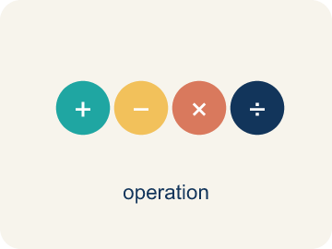 | The Distributive Property La propiedad distributiva  Multiply a factor by every term inside parentheses.  Example: 3(x + 4) = 3x + 12
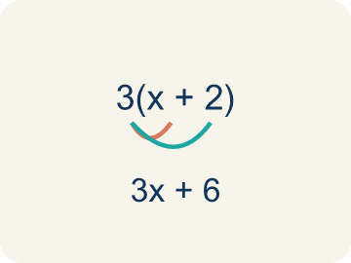 | Distributive Property Propiedad distributiva  Multiplying a number by everything inside the parentheses: a(b + c) = ab + ac.  Example: 3(4 + 5) = 3×4 + 3×5 = 12 + 15 = 27 — the 3 gets 'distributed' to both the 4 and the 5
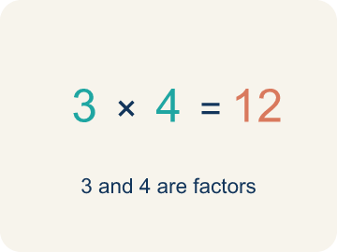 | Factor Factor  A factor of a whole number divides it evenly, with no remainder. For example, 3 is a factor of 12 because 12 ÷ 3 = 4.  Example: In 3(x + 2), the 3 is the factor outside the parentheses that multiplies each term inside
Expand Desarrollar
To multiply out the parentheses in an expression.
Example: Expand 2(n + 6): multiply 2 × n = 2n and 2 × 6 = 12, so 2(n + 6) = 2n + 12
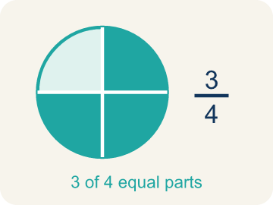 | Equivalent Equivalente  Expressions that always have the same value.  Example: 3(x + 4) and 3x + 12 always give the same answer: when x = 2, both = 18; when x = 10, both = 42
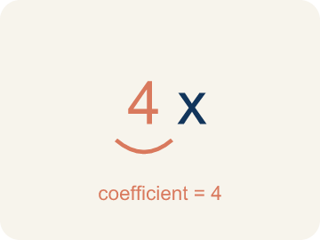 | Coefficient Coeficiente  The number in front of a letter, like the 3 in 3x.  Example: In 6x + 15, the coefficient of x is 6 — it came from distributing in 3(2x + 5)
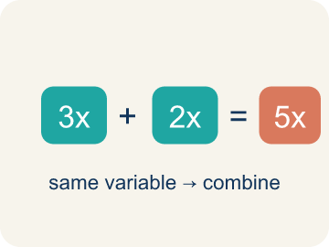 | Like terms Términos semejantes  Terms with the same letter raised to the same power, like 2x and 5x.  Example: 4x + 2x = 6x (combine coefficients); 4x + 2y cannot be combined (different variables)

Guided Notes
Fill in each blank as we go. Use the Word Bank to help you.
WORD BANK
The Distributive Property • Distributive Property • Factor • Expand • Equivalent • Coefficient • Like terms

1. a(b + c) = ab + ________________ — the factor reaches ________________ term.
2. The rule that a(b + c) = ab + ac is the ________________.
3. To rewrite a sum as a product, like 3x + 12 = 3(x + 4), is to ________________.
4. To multiply out a product over a sum, like 3(x + 4) = 3x + 12, is to ________________.
5. Two expressions that always have the same value are ________________.
6. A number multiplied by a variable is a ________________.
7. Terms with the same variable part are ________________.

Write About the Math
Use the distributive property to find the total cost. Which way of calculating is easier for you?
Usa la propiedad distributiva para hallar el costo total. ¿Qué manera de calcular te resulta más fácil?
Say your answer to a partner first. Then write it, using at least two of these words:
☐ The Distributive Property · La propiedad distributiva
☐ Distributive Property · Propiedad distributiva
☐ Factor · Factor
☐ Expand · Desarrollar
☐ Equivalent · Equivalente
Model: The distributive property multiplies the 3 by each item, giving the same total. — Students explain the 3 distributes to both the ticket and the snack (3 × 15 + 3 × 5 = 45 + 15 = 60), matching 3 × 20, and use the word equivalent.

Start Most language support
Complete the frames. Use the word bank.
Completa las oraciones. Usa el banco de palabras.
8(12 + 9) = 8 × ___ + 8 × ___ = ___ + ___ = ___. I think the ___ form is easier because ___.
My answer is ___ because ___.
Mi respuesta es ___ porque ___.

Build Some language support
Write two connected sentences. Use because, so, or but.
Escribe dos oraciones conectadas. Usa porque, entonces o pero.
My claim is ___.
Mi afirmación es ___.
My evidence is ___, so ___.
Mi evidencia es ___, entonces ___.

Explain Light language support
Write a claim, give math evidence, and explain your reasoning.
Escribe una afirmación, da evidencia matemática y explica tu razonamiento.

Check Your Explanation three quick checks
☐ I answered the question.
☐ I used math evidence: numbers, an equation, or a model.
☐ I used at least two math words.

Worked Example

Watch & Read I Do — follow along with your teacher
Ticket Pricing
You're selling concert bundles at the music studio. Each bundle includes a ticket ($15) and a snack ($5). If 3 people each buy a bundle, you can calculate the total as 3(15 + 5) OR as 3 × 15 + 3 × 5. Either way, the total is the same — $60! This is the distributive property.

Think about:
• Why do both methods give the same total?
• What does the 3 represent in 3(15 + 5)?
• How is 3(15 + 5) related to 3 × 15 + 3 × 5?
• What if 10 people bought bundles — which way would be faster to calculate?
• Does this work with subtraction too, like 4(20 − 3)?

Solved Example I Do — watch each step
Problem: Expand 6(n + 3) using the distributive property.
A) 6n + 18
B) 6n + 3
C) n + 18
D) 6n + 9
Step 1: 6(n + 3) = 6 × n + 6 × 3 = 6n + 18.
Answer: A. 6n + 18

Guided Practice

Solve Together We Do — work with your class
Problem: Expand 4(5 − 2) using the distributive property.
A) 12
B) 20 − 2
C) 9
D) 22
Step 1:

Step 2:

Answer:

A music studio is ordering supplies for 8 practice rooms. Each room needs a music stand ($12) and a stool ($9). The total cost can be written as 8(12 + 9).
Use the distributive property to find the total cost. Which way of calculating is easier for you?

Sentence frame: 8(12 + 9) = 8 × ___ + 8 × ___ = ___ + ___ = ___. I think the ___ form is easier because ___.

Turn & Talk discuss with a partner
1. [Launch] Each bundle is a ticket ($15) and a snack ($5). For 3 people, why does 3(15 + 5) give the same $60 as 3 × 15 + 3 × 5?
Start with: Both give $60 because I distribute the 3 to ___ and ___.
Las dos dan $60 porque distribuyo el 3 a ___ y ___.
Word bank: Distributive Property, Factor, Expand, Equivalent
2. [Explore] When you expand 5(2x + 4), why must the 5 multiply BOTH terms inside the parentheses?
Start with: I distribute the 5 to ___ and ___, so 5(2x + 4) = ___.
Distribuyo el 5 a ___ y ___, así 5(2x + 4) = ___.
Word bank: Distributive Property, Expand, Factor, Equivalent
3. [Connect] For 8 practice rooms each needing a music stand ($12) and a stool ($9), the cost is 8(12 + 9). How do you use the distributive property to find the total, and which form is easier for you?
Start with: 8(12 + 9) = 8 × ___ + 8 × ___ = ___.
8(12 + 9) = 8 × ___ + 8 × ___ = ___.
Word bank: Distributive Property, Factor, Expand, Equivalent
4. [Practice] During practice on The Distributive Property, what strategy did you use when a problem felt tricky?
Start with: When a problem felt tricky, I ___ so that ___.
Cuando un problema fue difícil, yo ___ para que ___.
Word bank: Distributive Property, Factor, Expand, Equivalent

Independent Practice

On Your Own You Do — show your work
Solve each problem. Show your thinking in the work box.

Level 1 Support extra scaffolding
1. Expand 3(x + 4) using the distributive property.
A) 3x + 12
B) 3x + 4
C) x + 12
D) 7x

2. When using the distributive property with a(b + c), you must multiply 'a' by:
A) Both b and c
B) Only b
C) Only c
D) b + c first, then multiply

Exit Ticket
Answer on your own. This shows what you learned today.
★ Which expression is equivalent to 7(x + 3)?
A) 7x + 21
B) 7x + 3
C) x + 21
D) 7x + 10

